City of Plainview HandiVan
ADA Compliance
Federal Transit Administration
Section 5311 Subrecipients

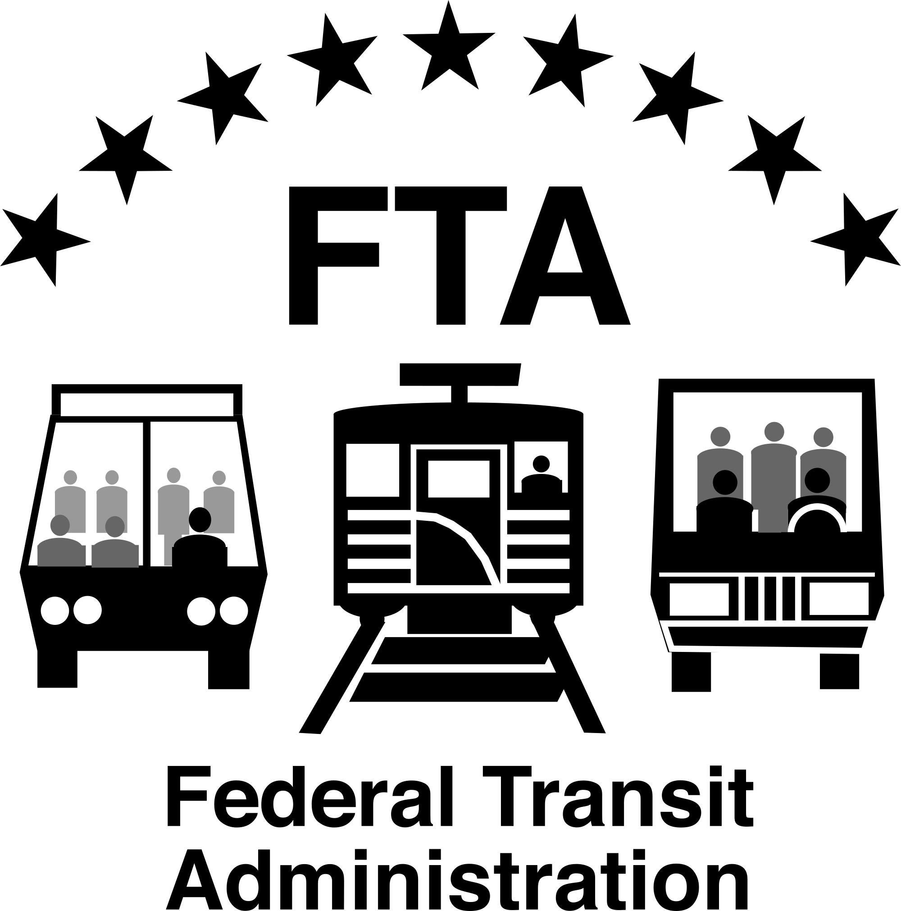

October 2021
TABLE OF CONTENTS

Notice Under The Americans With Disabilities Act (ADA) 2
Authorities 3
Complaint Procedures 4
Filing of Complaint 4
Investigation of Complaint 5
Dismissal of Complaint 6
ADA Discrimination Complaint Form 7
ADA Complaing Log………………………………………………………………………………...……8
FTA's Reasonable Modification Rule 10
Reasonable Modification Complaint Process and Form 10
Complaint Appeals Process 12
Reasonable Modification/Accommodation Complaint Form 13

NOTICE UNDER THE AMERICANS WITH DISABILITIES ACT (ADA)
City of Plainview HandiVan
In accordance with the requirements of Title II of the Americans with Disabilities Act of 1990 (ADA), City of Plainview HandiVan will not discriminate against qualified individuals with disabilities on the basis of disability in its services, programs or activities.
Employment: City of Plainview HandiVan does not discriminate on the basis of disability in its hiring or employment practices and complies with all regulations promulgated by the U.S. Equal Employment Opportunity Commission under Title I of the ADA.
Effective Communication: City of Plainview HandiVan will generally, upon request, provide appropriate aids and services leading to effective communication for qualified persons with disabilities so they can participate equally in the City of Plainview HandiVan programs, services, and activities, including qualified sign language interpreters, documents in Braille, and other ways of making information and communications accessible to people who have speech, hearing, or vision impairments.
Modifications to Policies and Procedures: City of Plainview HandiVan will make all reasonable modifications to policies and programs to ensure that people with disabilities have an equal opportunity to enjoy all of its programs, services, and activities. For example, individuals with service animals are welcomed in our offices, even where pets are generally prohibited.
Anyone who requires an auxiliary aid or service for effective communication, or a modification of policies or procedures to participate in a program, service, or activity of City of Plainview HandiVan, should contact:
Courtney Retzlaff
City Clerk
POB 757
205 W Locust
Plainview, NE 68769
402-582-4928
cretzlaff@cityofplainviewne.com
The ADA does not require City of Plainview HandiVan to take any action that would fundamentally alter the nature of its programs or services.
Complaints that a program, service, or activity of City of Plainview HandiVan is not accessible to persons with disabilities should be directed to the Coordinator listed above.
City of Plainview HandiVan will not place a surcharge on a particular individual with a disability or any group of individuals with disabilities to cover the cost of providing auxiliary aids/services or reasonable modifications of policy, such as retrieving items from locations that are open to the public but are not accessible to persons who use wheelchairs.

Authorities
Section 504 of the Rehabilitation Act of 1973, as amended, provides that “No otherwise qualified disabled individual in the United States, as defined in section 7(6), shall, solely by reason of his disability, be excluded for the participation in, be denied the benefits of, or be subjected to discrimination under any program or activity receiving Federal financial assistance.”
29 USC 794 (October 29, 1992 to the Rehabilitation Act of 1973) substitutes “a disability” for “handicaps” and “disability” for “handicap”.
49 CFR Part 27.13 (Nondiscrimination on the Basis of Disability in Programs and Activities Receiving or Benefiting from Federal Financial Assistance) states, “This part applies to each recipient of Federal financial assistance from the Department of Transportation and to each program or activity that receives or benefits from such assistance”.
49 CFR Part 28.102 (Enforcement of Nondiscrimination on the Basis of Disability in Programs or Activities Conducted by the Department of Transportation) states, “This part applies to all programs or activities conducted by the Department of Transportation except for programs and activities conducted outside the United States that do not involve individuals with disabilities in the United States.”
28 CFR Part 35 (Judicial Administration) states that: “The purpose of this part is to effectuate Subtitle A of Title II of the ADA which prohibits discrimination on the basis of disabilities by public entities.
49 CFR part 27 (Nondiscrimination on the Basis of Disability in Programs and Activities Receiving or Benefiting from Federal Financial Assistance) states, “The purpose of this part is to carry out the intent of Section 504 of the Rehabilitation Act of 1973 (29 USC 794) as amended, to the end that no otherwise qualified disabled individual in the United States shall, solely by reason of his or her disability, be excluded from the participation in, be denied the benefits of, or be subjected to discrimination under any program or activity receiving Federal financial assistance.”
49 CFR Part 28-140 (Employment) states that, “(a) No qualified individual with disabilities shall, on the basis of disability, be subjected to discrimination in employment under any program or activity conducted by the Department,” and “(b) The definitions, requirements, and procedures of Section 504 of the Rehabilitation Act of 1973 (29 USC 791), as established by the Equal Employment Opportunity Commission in 29 CFR part 1613, shall apply to employment in federally conducted programs or activities.
29 CFR Part 1613 (Equal Employment Opportunity in the Federal Government) states that: “It is the policy of the Government of the United States…to provide equal opportunity in employment for all persona to prohibit discrimination in employment because of race, color, religion, sex, or national origin and to promote the full realization of equal employment opportunity through a continuing affirmative program in each agency.”
42 USC Part 12101-12213 (The Americans with Disabilities Act of 1990) states that: “No covered entity shall discriminate against a qualified individual with a disability because of the disability of such individual in regard to job application procedures, the hiring, advancement, or discharge of employees, employee compensation, job training, and other terms, conditions, and privileges of employment.”
Complaint Procedures
No person in the United States shall, on the ground of race, color, or national origin be excluded from participation in, be denied the benefits of, or be subjected to discrimination under any program or activity receiving Federal financial assistance.
These procedures apply to all complaints filed under Section 504 of the Rehabilitation Act of 1973, relating to any program or activity administered by City of Plainview HandiVan or its sub-recipients, consultants and/or contractors. Intimidation or retaliation of any kind is prohibited by law.
Persons Eligible to File: any individual or group of individuals, or entity who believes that he or she or any specific class of persons has been subjected to discrimination or retaliation prohibited by any of the Civil Rights Authorities based upon race, color, sex, age, national origin or disability may file a written complaint.
 |  |  | DISCRIMINATION: an act (or action) or inaction whether intentional or unintentional, through which a person in the United States, based on race, color, sex, age, national origin, or disability has been subjected to unequal treatment under any program or activity receiving Federal financial assistance.
Two complaint forms are available for the individual. The ADA Complaint Form (Appendix A) is for individuals that believe City of Plainview HandiVan programs, services, or activities may be discriminatory. The Reasonable Modification Complaint form is to request a modification to ensure City of Plainview HandiVan programs and activities are accessible.
Filing of Complaint
1. |  | Complaints may be filed by the affected individual or a representative of that individual.
2. |  | Complaints must be in writing and contain as much information as possible about the alleged discrimination. City of Plainview HandiVan has prepared a Complaint Form to be used for the convenience of the complainant. The written complaint should include:
 |  | a. |  | Complainant’s name, address and telephone number,
 |  | b. |  | A detailed description of the issues,
 |  | c. |  | Name and job titles of individuals perceived as parties in the complaint.
 |  | Complaints received by telephone will be placed in writing and provided to complainant for confirmation or revision, and signature before processing.
3. |  | Complaint forms will be available on www.cityofplainviewne.com or by contacting Courtney Retzlaff, City Clerk. Complaints and substantiating information should be sent to:
 |  | Kari Ruse  NDOT Transit Manager  1400 Highway 2  PO Box 94759  Lincoln, Nebraska 68509  402-479-4694 |  |  | - OR - | Courtney Retzlaff  City Clerk  POB 757  205 W Locust Ave  Plainview, NE 68769  402-582-4928
Alternate means of filing a complaint will be made available to accommodate persons with disabilities upon request.
4. |  | A complaint should be filed as soon as possible but must be no later than 180 calendar days after the complainant becomes aware of the alleged discrimination, unless the time for filing is extended by the designated agency for good cause shown.
5. |  | Upon receipt of the complaint, City of Plainview HandiVan will notify the Nebraska Department of Transportation, to coordinate all further activity regarding the complaint.
6. |  | The City Clerk, will contact the complainant to:
 |  | a. |  | Acknowledge receipt of the complaint by the investigator,
 |  | b. |  | Confirm that the complainant wishes to go forward with the complaint,
 |  | c. |  | Confirm that there are allegations that need to be investigated and resolved, and
 |  | d. |  | Gather additional facts and further clarify the complaint.
Investigation of Complaint
An Investigator will review and investigate the complaint. As part of the review, the investigator will at minimum:
 |  | 1. |  | Gather relevant documentation from the complainant not included in the complaint, such as forms, memos, letters, and photographs information
 |  | 2. |  | Contact complainant to arrange and conduct interview, if needed
 |  | 3. |  | Maintain log of all activities associated with complaint.
 |  | 4. |  | Complete Investigative Report of information, findings, photos, and recommendations for correction to the Nebraska Department of Transportation.
A copy of the complaint, together with a copy of the Agency’s report of investigation, shall be forwarded to the Nebraska Department of Transportation within 60 days of the date the complaint was received by the State. All complaints are to be kept on file and made available to FTA upon request.
An ADA finding of violation or no violation is a Federal decision that cannot be delegated.
Dismissal of Complaint
A decision to dismiss a complaint cannot be designated to the agency. A decision to dismiss a complaint can be done for the following reasons:
 | - The complaint is untimely filed
 | - The complaint does not allege a basis covered by the statutes for which City of Plainview HandiVan is responsible
 | - The complaint does not allege any harm with regard to covered programs or statutes
 | - The complainant requests the withdrawal of the complaint
 | - The complainant fails to respond to repeated requests for additional information needed to process the complaint
 | - The complainant cannot be located after reasonable attempts
City of Plainview HandiVan has developed the following complaint procedures:
 | - ADA Complaints
 | - Reasonable Modification Complaints/Requests

ADA DISCRIMINATION COMPLAINT FORM
City of Plainview HandiVan
Complainant: | Phone:
Address: (City, State, Zip): | Email:
Person Discriminated Against if Different from Above: | Phone:
 | Email:
Date of Incident:
Date and place of alleged discriminatory actions. Please include earliest date of discrimination and most recent date of discrimination.
Explain as briefly and clearly as possible what happened and how you were discriminated against. Indicate who was involved. Be sure to include how other persons were treated differently than you. Also, attach any written material pertaining to your complaint (attach additional pages, if necessary).

The complaint will not be accepted if it has not been signed. Please sign and date this complaint form below. You may attach any written materials or other supporting information that you believe is relevant to the complaint.

_____________________________________________________  Signature |  |  |  |  |  | ___________________________________  Date
Attachments: |  | Yes |  |  | No
Submit completed form to: |  |  |  | Courtney Retzlaff, City Clerk  City of Plainview HandiVan  POB 757  205 W Locust Ave  Plainview, NE 68769  402-582-4928  cretzlaff@cityof plainviewne.com

- AGENCY USE ONLY -
Received By: | Date:

ADA COMPLAINT LOG
City of Plainview HandiVan
ADA COMPLAINT LOG
Investigator | Complaint | Sub- recipient | Date Filed | Date of Final Report | Disposition

FTA's Reasonable Modification Rule
In March 2015, the Federal Transit Administration issued a final rule concerning reasonable modification of transportation policies and practices. The ruling mandates that all public transit providers must make reasonable modifications/accommodations by making changes to policies, practices and procedures if needed by an individual to participate in the recipient's program or activity. Modifications will be made to avoid discrimination on the basis of disability.
The following exceptions apply:
 | 1. | When the modification/accommodations would cause a direct threat to the health or safety of others;
 | 2. | Would result in a fundamental alteration of service;
 | 3. | Without the requested modification, the individual with a disability is able to fully use the entity's services, programs, or activities for their intended purpose.
The reasonable modification rule has implications for every rural public transportation system. Disabled and elderly passengers can now request that you alter your standard operating procedures to ensure they have access to your services. For example, if your policy states that you provide curb to curb service a wheelchair bound person could request door to door service. If that request does not meet the exceptions as noted above, the accommodation should be approved.
To comply with the reasonable modification/accommodation rule, rural public transit systems receiving Section 5311funds will have to implement the following procedures:
 | 1. | Make information about how to contact the transit system to make requests for reasonable modifications readily available to the public through the same means it uses to inform the public about its policies and practices.
 | 2. | The information shall be accessible to and usable by individuals with disabilities.
 | 3. | Designate a responsible employee to coordinate compliance.
 | 4. | Adopt procedures that incorporate due process standards and provide for the prompt and equitable resolution of requests for reasonable accommodation.
 | 5. | Individuals requesting modifications shall describe what they need in order to use the service. The request does not need to include the term "reasonable modification."
 | 6. | When possible, the request and resulting modification shall be determined prior to providing transportation service. In some circumstances, transit drivers shall make the determination to provide or deny a service modification in the field. The driver may contact transit system management before making the determination.
Rider handbooks and policy/procedural manuals must be updated to indicate the transit system is in compliance with the requirements listed above. Template complaint and complaint appeal forms will be provided by NDOT.
Please note, in 49 CFR Part 37 Subsection 37.S(h) the regulation states the following:
 | It is not discrimination under this part for an entity to refuse to provide service to an individual with disabilities because that individual engages in violent, seriously disruptive, or illegal conduct or represents a direct threat to the health or safety of others. However, an entity shall not refuse to provide service to an individual with disabilities solely because the individual's disability results in appearance or involuntary behavior that may offend, annoy, or inconvenience employees of the entity or other persons.
If you have any questions, please contact City of Plainview HandiVan.

Reasonable Modification Complaint Process and Form
City of Plainview HandiVan is committed to ensuring that the department complies with the Americans with Disabilities Act (ADA), including Section 49 CFR Parts 27 and 37. Transportation entities are required to make reasonable modifications / accommodations to policies, practices, and procedures to avoid discrimination and ensure that programs are accessible to individuals with disabilities.
Any person who wishes to file a complaint regarding a request for Reasonable Modification may file a written complaint.
Reasonable Modification Requests should be mailed or emailed to:
Courtney Retzlaff, City Clerk
City of Plainview HandiVan
POB 757
205 W Locust Ave
Plainview, NE 68769
402-582-4928
cretzlaff@cityofplainviewne.com
 | 1. | To file a reasonable modification request, the attached complaint form should be completed and submitted.
 | 2. | All reasonable modification request must be submitted in writing. If the complainant is unable to write because of a disability and needs assistance in completing the form Agency staff will assist by taking the reasonable modification request by phone.
 | 3. | City of Plainview HandiVan will begin an investigation within fifteen (15) working days of receipt of a written reasonable modification request.
 | 4. | City of Plainview HandiVan will contact the complainant in writing no later than thirty (30) working days after receipt of a reasonable modification request. If the complainant fails to provide the requested information in a timely basis, City of Plainview HandiVan shall administratively close the reasonable modification request.
 | 5. | City of Plainview HandiVan shall complete the investigation within ninety (90) days or receipt of the reasonable modification request. If additional time for investigation is needed, the complainant will be contacted.
 | 6. | A written response will be prepared by City of Plainview HandiVan, which will include a summary of why the request was denied or grants and recommended action. The complainant will have fifteen (15) working days from receipt of the response to appeal a denial. If no appeal is received, the reasonable modification request will be closed and no further action will be taken.

Complaint Appeals Process
A complainant, who is not satisfied with City of Plainview HandiVan response to a complaint regarding a request for reasonable modification, has the right to appeal.
City of Plainview HandiVan will review you appeal and respond within twenty-one (21) working days from the date of the appeals request.
The decision to allow or deny a request for reasonable modification will be based on information from the complainant and ADA regulations and exceptions to the rule. These exceptions are:
 | 1. | When the modification/accommodation would cause a direct threat to the health or safety of others;
 | 2. | Would result in a fundamental alteration of the service;
 | 3. | Would not actually be necessary in order for the individual with a disability to access the transportation entity's service; or

Reasonable Modification/Accommodation Complaint Form
For assistance in completing this form, please contact Courtney Retzlaff
Please complete this form. Fields marked with an asterisk (*) are required.
Person filling out this form:
*Name:
*Address:
*Telephone: (preferred)
*Email:
Person(s) Refused Reasonable Accommodation (if other than the complainant):

Are you filling this complaint on your own behalf? |  |  |  |  |  |  |  |  |  |  |  |  |  |  |  |  |  | Yes * |  |  |  |  |  |  |  |  | No
* If you answered "yes" to this question, go to next section.
If not, please supply the name and relationship of the person for whom you are complaining:
(Name and Relationship)

Please confirm that you have obtained the permission of the aggrieved party if you are filing on behalf of that party: |  |  |  |  |  |  |  |  |  |  |  |  |  |  |  |  |  |  |  |  |  |  | Yes |  |  |  |  |  |  | No
*Primary type of disability? Please check specific disability:
 | Mobility |  |  |  |  |  |  | cognitive/intellectual/developmental |  |  |  |  |  |  |  |  |  |  |  |  |  | learning |  |  |  |  |  |  |  |  |  | vision
 |  | Mental/psychiatric |  |  |  |  |  |  |  | Hearing |  |  | Seizure |  |  |  | HIV/Aids |  |  |  |  |  |  |  |  |  |  | Diabetes
 |  | Other or not listed
* Describe your request for a reasonable accommodation:
Specific location where we may need to take action (if applicable):
Are you able to use the public transportation system without this modification/accommodation?

Yes No

Please explain:

Signature and date required below:
______________________________________________ |  |  |  |  |  |  |  |  |  |  |  |  |  |  |  |  |  |  | ____________________________
Signature |  |  |  |  |  |  |  |  |  |  |  |  |  |  |  |  |  |  | Date
You may submit at the address below by email, fax or mail this form to:
Name: |  |  |  |  |  | _______________________________________________________________
Organization: |  |  |  |  |  | _______________________________________________________________
Address: |  |  |  |  |  | _______________________________________________________________
City: |  |  | ____________________________ |  |  |  |  |  |  |  |  | State: |  | ______________________ |  |  |  |  |  |  |  |  |  |  |  |  |  |  |  |  | Zip: |  | ______
Email: |  |  |  | _____________________________________________________________________
Phone: |  |  |  |  | _____________________________________________________________________

